

**Team: OnlyDevs**

**External Design Document – Version 1.0**

**COMP229 –Web Application Development**

**March 22, 2025**

**Team Members:**

**Alim Rashyani – 301497158**

**Delannie Teodoro – 301486294**

**Drashtam Banker – 301497001**

**Parth Kevadiya – 301492239**

**Numaan Baig – 301498091**

**Zeel Vekariya - 301489564**

**Contents**

**Introduction** 3

**Program Overview** 3

**Wireframes** 3

-Landing Page: 4

- Team Logo: 5

- Login Section: 5

- Sign Up Section: 6

- Dashboard Overview: 6

- Product Section: 7

- Product Info Section: 8

- Add Product Form: 9

**Initial Screenshots** 10

-Backend and MongoDB Connection 10

-Frontend Landing Page 11

-Frontend Login Page 12

-Frontend Signup Page: 12

**Conclusion** 13

# **Introduction**

This document outlines the initial design and functionality of our web application developed for the COMP229 First Release. The purpose of this External Design Document (EDD) is to provide a clear overview of our project’s structure, features, and progress at this stage, focusing on the database-backend integration, CRUD operations, and authentication mechanisms as required for the first release.

This is a draft version that will evolve as our project advances toward its final iteration. Our team is developing an Inventory Management System (IMS) to assist businesses in tracking, managing, and optimizing their inventory in real time. The IMS enables efficient stock management, order processing, and reporting through a user-friendly web application, ensuring that businesses can prevent stock shortages or overstocking while streamlining their operations.

# **Program Overview**

We are building an Inventory Management System (IMS) to assist businesses in tracking, managing, and optimizing their inventory efficiently. The IMS provides a web-based solution that ensures real-time stock updates, streamlined order processing, and comprehensive inventory oversight, helping businesses maintain optimal stock levels.

The primary objective of the IMS is to enable users to perform full CRUD (Create, Read, Update, Delete) operations on inventory items, facilitating seamless management of products, orders, and stock data. It aims to improve operational efficiency by offering features like low-stock alerts, product categorization, and reporting tools tailored to business needs. The system targets business owners, warehouse staff, and administrators who require a reliable tool to monitor and control inventory workflows.

For this First Release, as part of COMP229 requirements, our focus is on establishing the database-backend integration using MongoDB, Node.js, and Express.js, implementing CRUD operations for inventory items, and incorporating JWT-based authentication and authorization. This release lays the foundation for core functionality, allowing users to securely log in, add, view, edit, and delete inventory records, with further enhancements planned for future iterations.

# **Wireframes**

The following wireframe represents the primary entry point of our Inventory Management System (IMS) for the COMP229 First Release. Created using Figma, this wireframe outlines the layout and user flow for the Landing Page, which integrates key functionalities such as user authentication, inventory management through CRUD operations, and an overview of the system’s features. The design ensures users can navigate the IMS efficiently from a single hub.

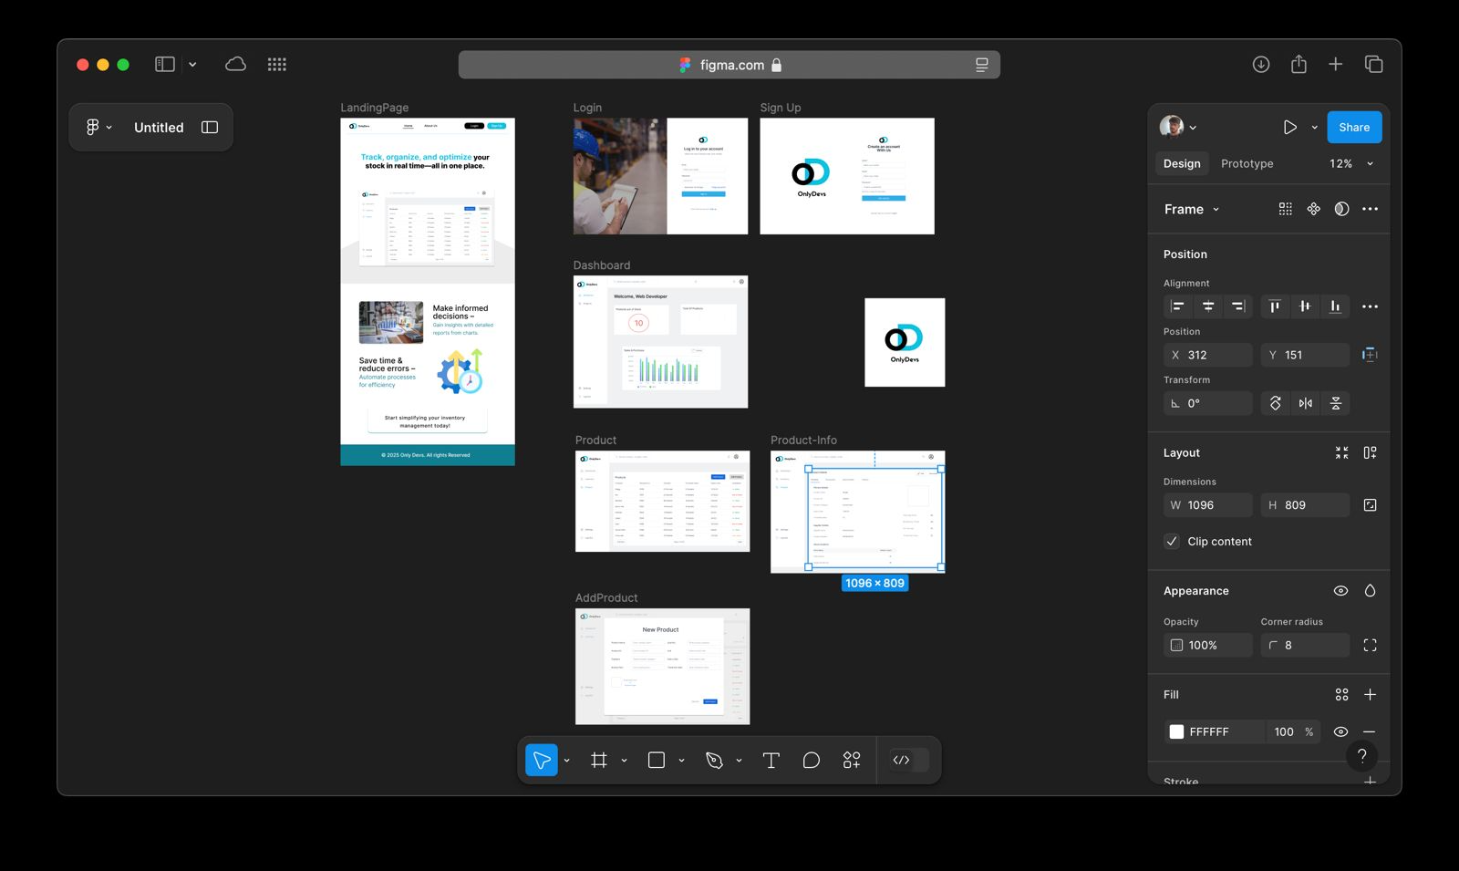

## -Landing Page:

This Landing Page serves as the central hub for the IMS, providing access to all major features for users, including authentication and inventory management tasks. It prominently displays the Team OnlyDevs logo at the top, establishing our brand identity, and offers an intuitive layout for users to log in, sign up, and interact with inventory data. The page is designed to guide users seamlessly into the system’s core functionalities.

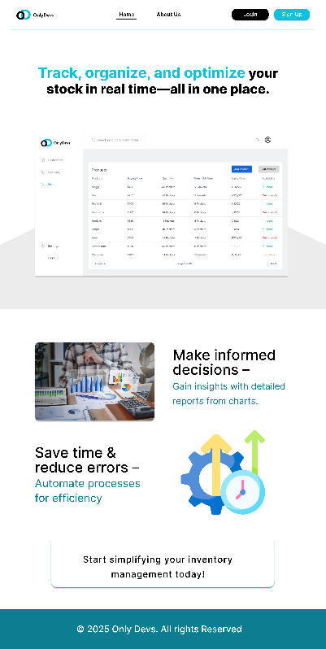

## - Team Logo:

Displays the Team OnlyDevs logo at the top for branding.



## - Login Section:

This page allows users to securely access the IMS by entering their credentials. It is the entry point for all users, including admins and warehouse staff, ensuring that only authorized individuals can manage inventory data.

Key UI Elements: -

- Username field: For entering the user’s email or username.

- Password field: For entering the user’s password.

- Login button: Submits the credentials for authentication.

- Sign Up link: Redirects to the registration page for new users.



## - Sign Up Section:

This page enables new users to register for the IMS by providing their details, creating an account for secure access. It supports the authentication functionality by allowing admins and warehouse staff to sign up before accessing inventory management features. The sign-up page complements the Login Page, ensuring all users can securely enter the system.

Key UI Elements:

- Full Name field: For entering the user’s full name.

- Email field: For entering the user’s email address, which will be used as their username.

- Password field: For setting the user’s password.

- Sign Up button: Submits the registration details to create a new account.

- Login link: Redirects to the Login Page for existing users.

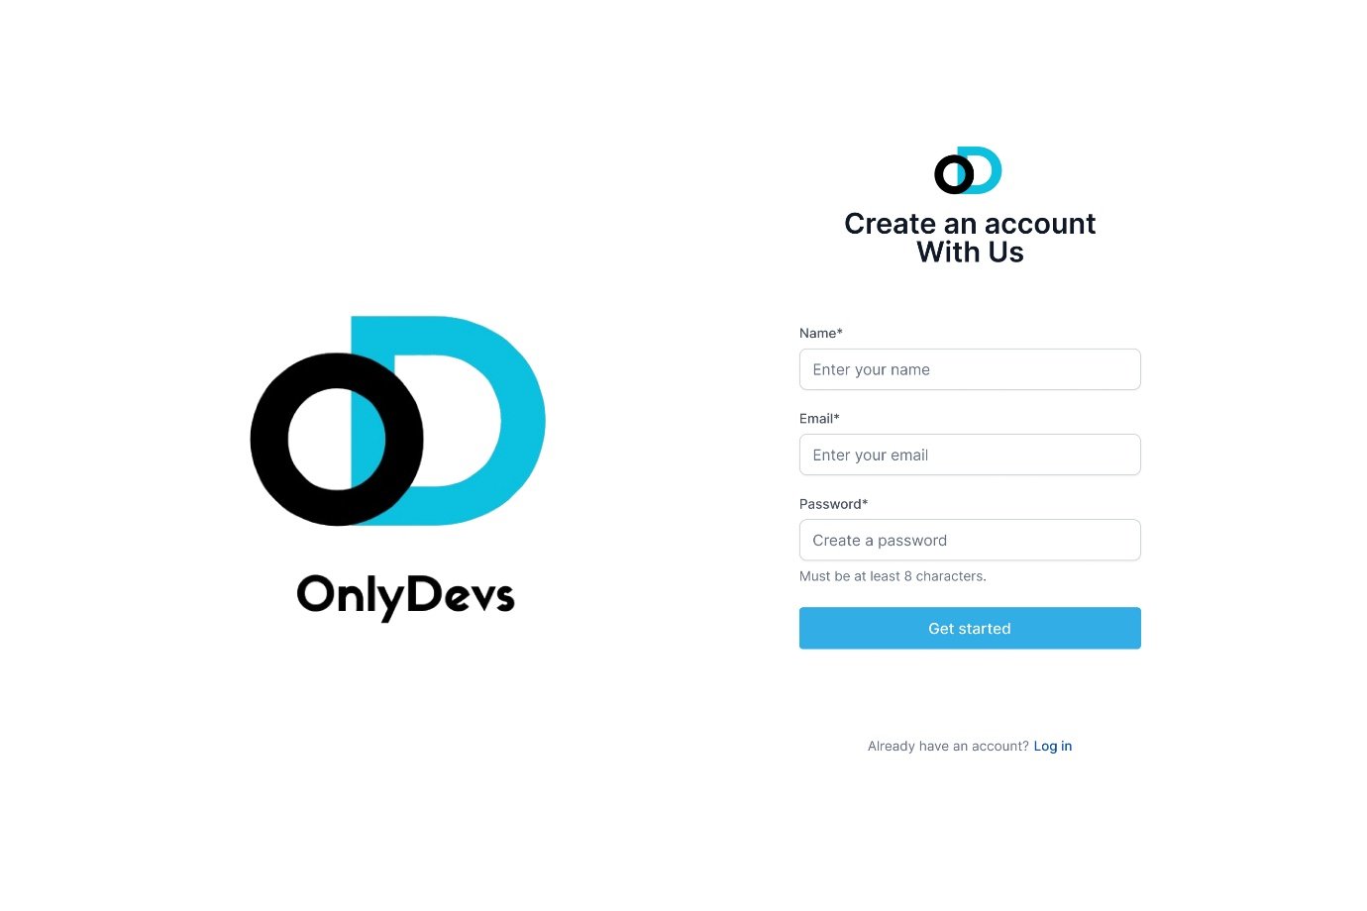

## - Dashboard Overview:

The Dashboard provides an overview of the inventory status for logged-in users. It displays key metrics and quick access to inventory management features, serving as the central hub for navigation.

Key UI Elements:

- Navigation bar: Links to Products, Orders, and Reports sections.

- Summary cards: Display metrics like total products or low-stock items.

- Graph: Visualizes inventory trends (e.g., stock levels over time).

- Quick action buttons: Links to add or view products.

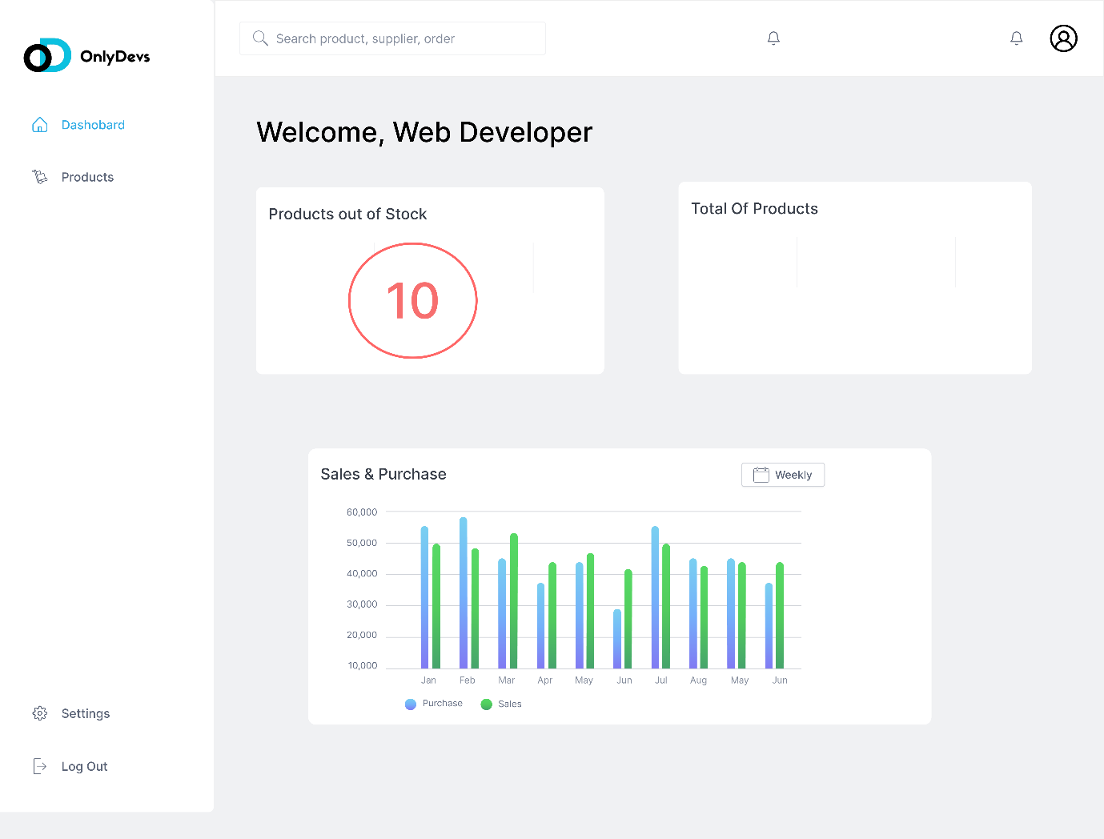

## - Product Section:

The Product List Page displays all inventory items in a tabular format, supporting the Read operation in CRUD. Users can view product details and access options to edit or delete items.

Key UI Elements: -

-Table: Lists products with columns for name, quantity, category, and actions.

- Edit button: Opens a form to update the selected product.

- Delete button: Removes the product from the inventory.

- Add Product button: Links to the Add Product Page.

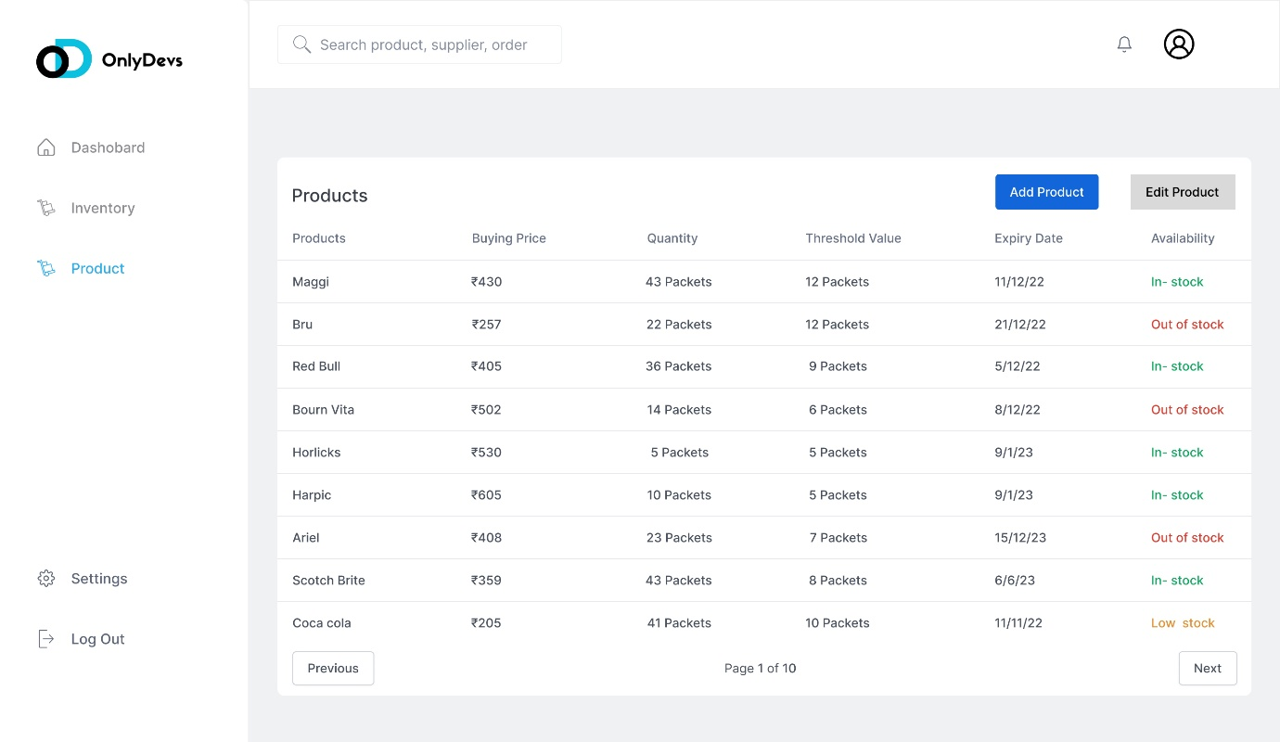

## - Product Info Section:

This page displays detailed information about a selected product in the IMS, supporting the Read operation in CRUD. It allows users, such as admins and warehouse staff, to view specific product details like price, SKU, and quantity, facilitating inventory oversight and decision-making. The Product Info Page is accessible from the Product List Page, providing a deeper look into individual inventory items.

Key UI Elements:

- Product Name: Displays the name of the selected product.

- SKU Field: Shows the product’s unique Stock Keeping Unit (SKU) identifier.

- Price Field: Indicates the product’s price.

- Quantity Field: Shows the current stock quantity.

- Back Button: Redirects the user to the Product List Page.

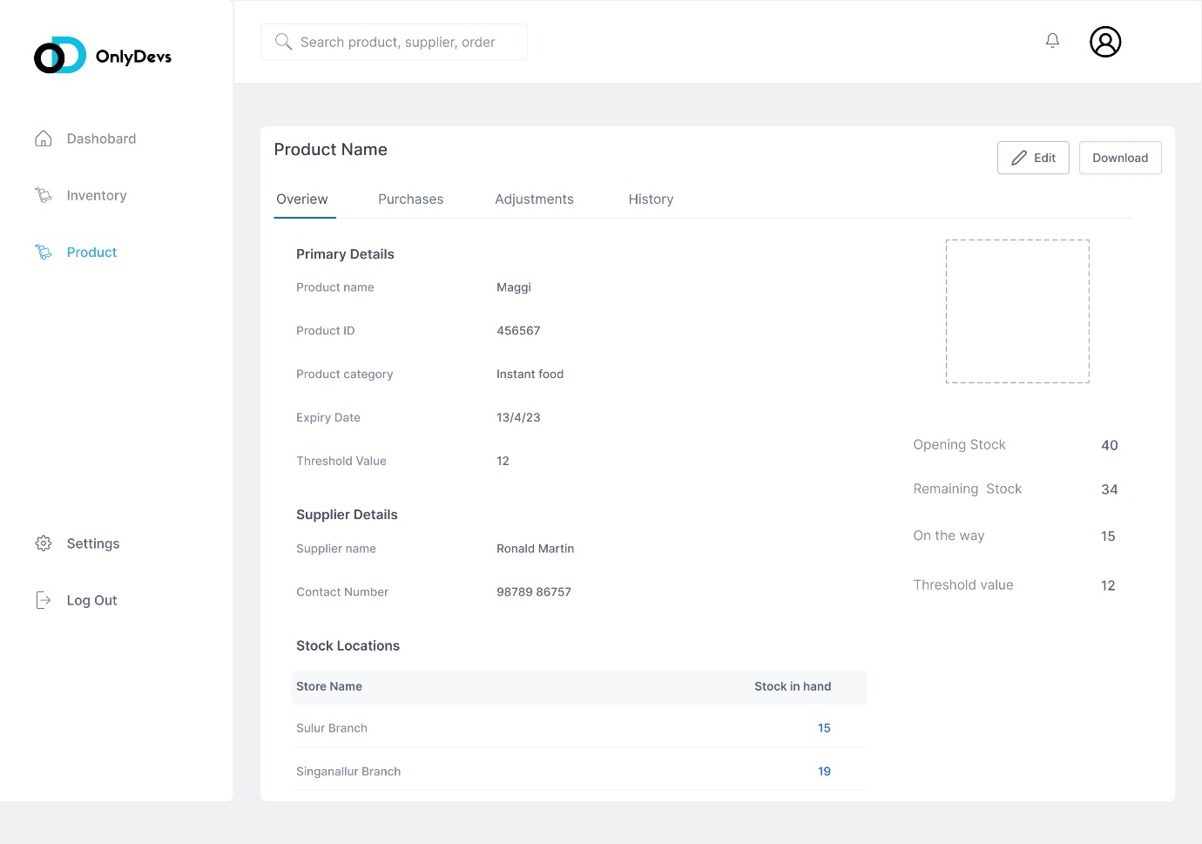

## - Add Product Form:

This page enables users to add new products to the inventory, supporting the Create operation in CRUD. Users can input product details, which are then saved to the MongoDB database.

Key UI Elements:

- Product name field: For entering the product’s name.

- Quantity field: For specifying the stock quantity.

- Category dropdown: For selecting the product category.

- Submit button: Adds the product to the inventory.

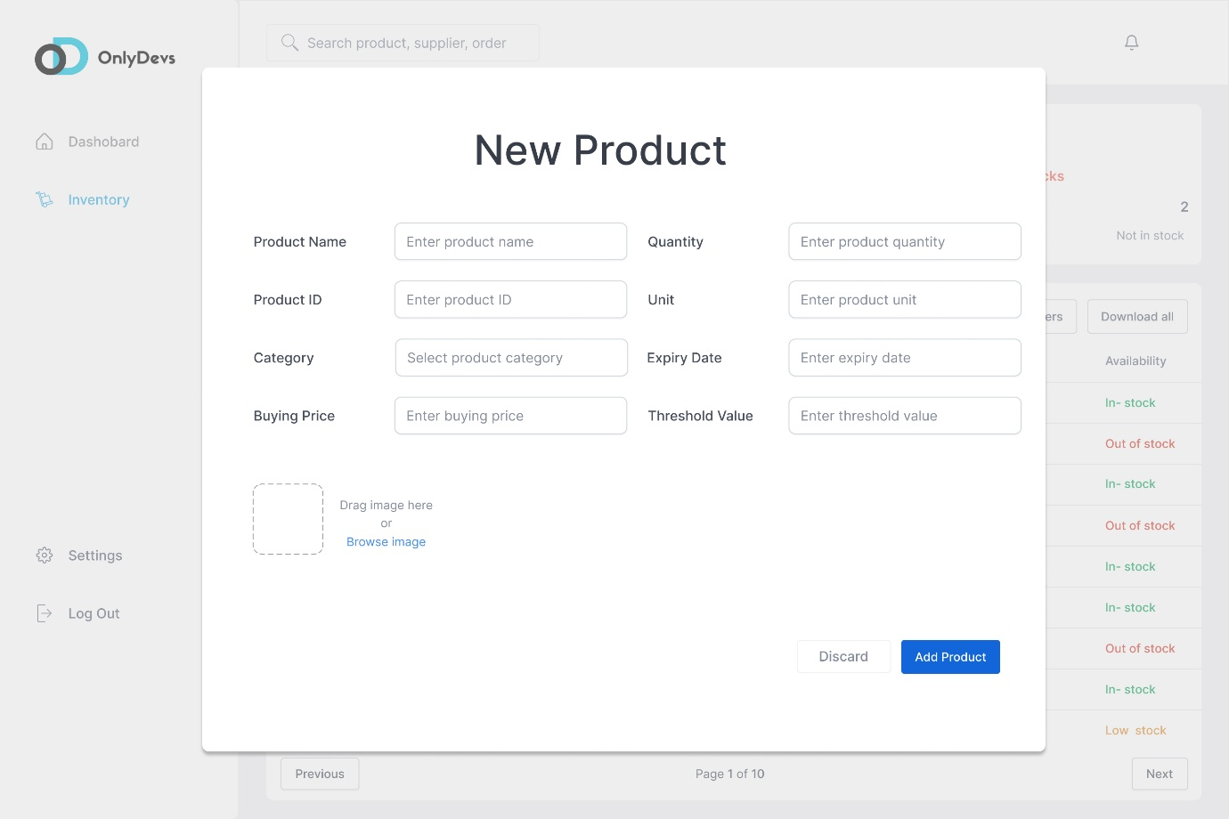

# **Initial Screenshots**

The following screenshot demonstrates the current state of our Inventory Management System (IMS) for the COMP229 First Release. It focuses on the backend functionality, which is a core requirement for this phase, including database-backend integration and the foundation for CRUD operations and authentication. Additional screenshots of the frontend will be included in future releases as the UI is refined.

## -Backend and MongoDB Connection

This screenshot shows the server.js file of our IMS backend, highlighting the successful connection to MongoDB, the database used for storing inventory data. The code snippet includes the MongoDB connection setup using the MongoClient, along with middleware configurations for CORS, Express, and routing for authentication and inventory management. The terminal output confirms that MongoDB is connected on port 5000, and the server is running on port 8397.

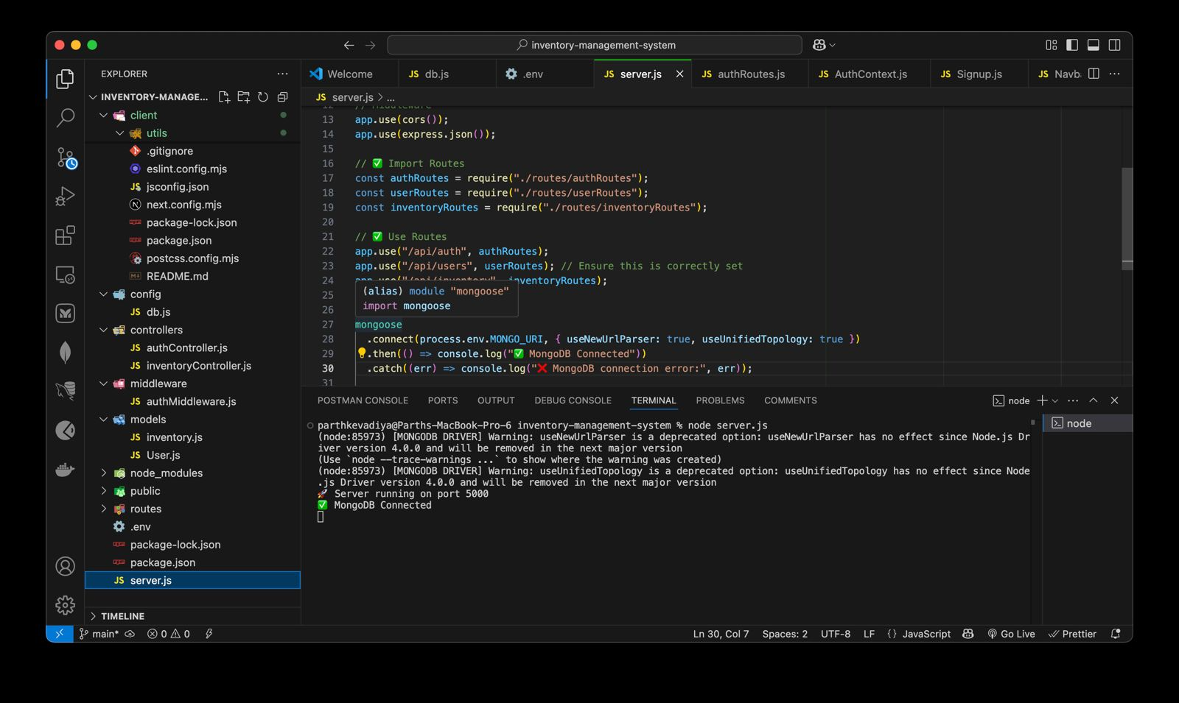

This screenshot focuses on the backend setup, with frontend UI development to be enhanced in later releases.

## -Frontend Landing Page

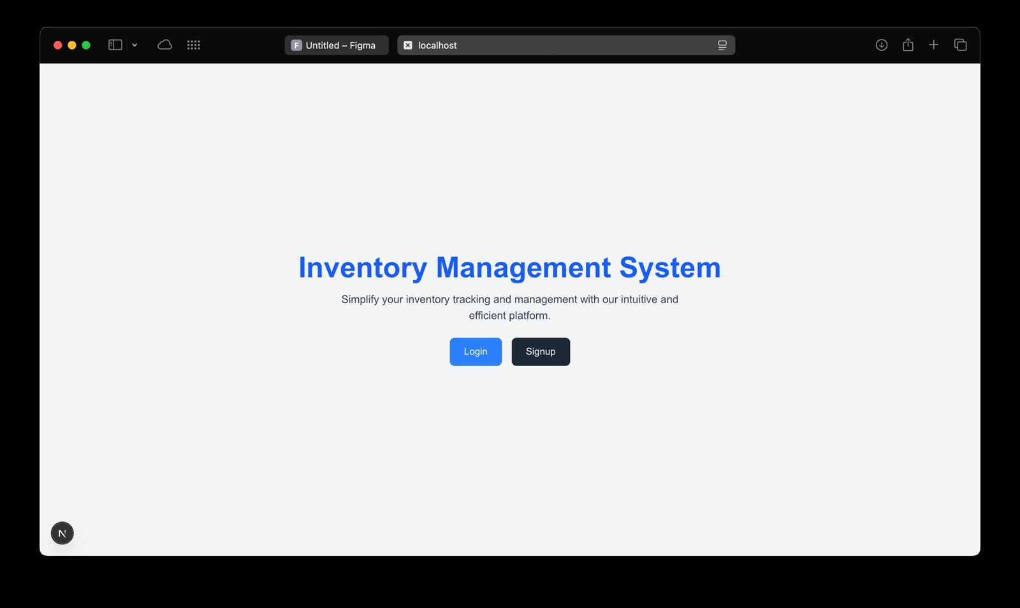

screenshot displays the Landing Page of our Inventory Management System (IMS), serving as the initial entry point for users. It provides options for users to either log in or sign up, supporting the authentication functionality required for the First Release. The page is designed to be simple and functional, guiding users to access the system securely before interacting with inventory management features.

This screenshot shows the initial frontend interface, with further UI enhancements and styling planned for future releases.

## -Frontend Login Page

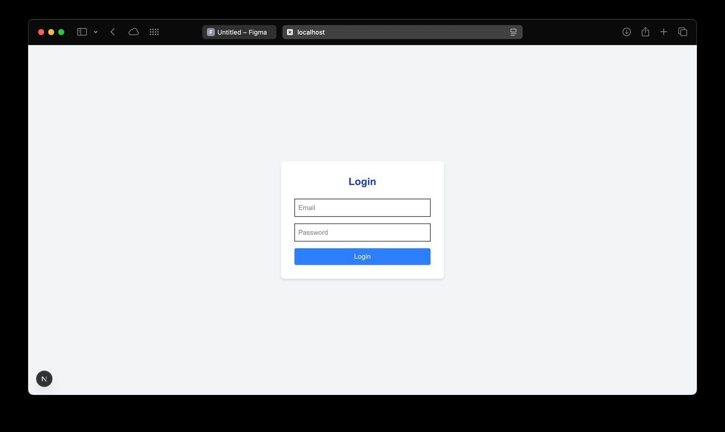

This screenshot displays the Login Page of our Inventory Management System (IMS), allowing users to securely access the system by entering their email and password. It supports the authentication functionality required for the First Release, enabling admins and warehouse staff to log in before managing inventory data. The page is designed to be straightforward, ensuring users can quickly authenticate and proceed to the dashboard.

This screenshot shows the login interface, with further UI enhancements and styling planned for future releases.

## -Frontend Signup Page:

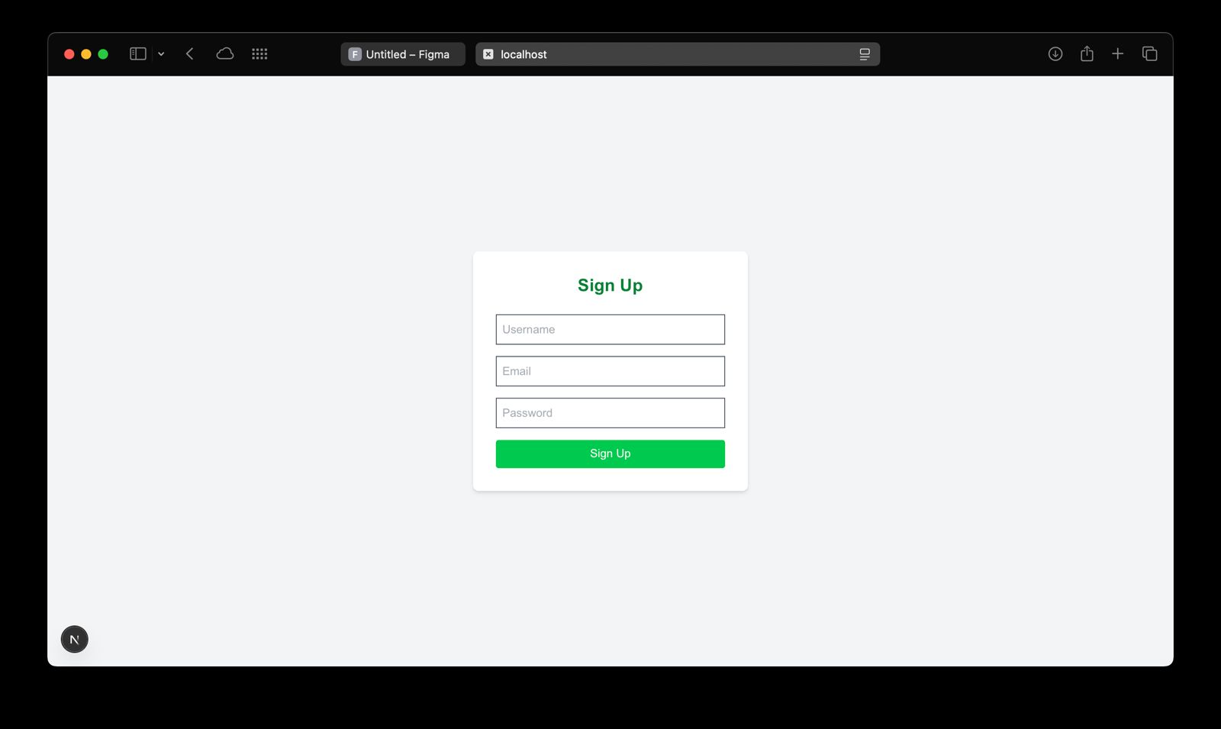

This screenshot displays the Sign Up Page of our Inventory Management System (IMS), allowing new users to register by providing their username, email, and password. It supports the authentication functionality required for the First Release, enabling admins and warehouse staff to create accounts before accessing inventory management features. The page is designed to be simple and functional, ensuring users can easily register and proceed to log in.

Status: Basic functionality implemented;

This screenshot shows the sign-up interface, with further UI enhancements and styling planned for future releases.

# **Conclusion**

This first release of our Inventory Management System (IMS) for COMP229 successfully establishes the core foundation of the application. We have implemented the database-backend integration using MongoDB, Node.js, and Express.js, set up JWT-based authentication with functional Login and Sign Up pages, and enabled basic CRUD operations for managing inventory items, as demonstrated through the backend code and frontend screenshots.

Future releases will focus on enhancing the user interface to improve the overall user experience, adding advanced features such as real-time low-stock alerts, comprehensive reporting and analytics for inventory trends, and order management capabilities. These enhancements will build on the solid foundation established in this release, ensuring the IMS becomes a robust tool for businesses to efficiently manage their inventory.